Cloud Architect, Cloud Network Engineer, Cloud Security Engineer, Cloud Administrator

Networking

**Lab Steps**

Task 1: Sign in to AWS Management Console

1. Click on the  button, and you will get redirected to AWS Console in a new browser tab.
2. On the AWS sign-in page,
   * Leave the Account ID as default. Never edit/remove the 12 digit Account ID present in the AWS Console. otherwise, you cannot proceed with the lab.
   * Now copy your **User Name** and **Password** in the Lab Console to the **IAM Username and Password** in AWS Console and click on the **Sign in** button.
3. Once Signed In to the AWS Management Console, Make the default AWS Region as **US East (N. Virginia) us-east-1.**
4. Select Maybe later in New AWS Console Home page pop-up

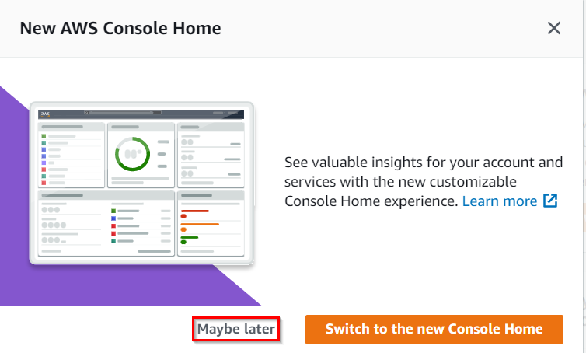

Task 2: Create S3 Bucket

1. Make sure you are in the **US East (N. Virginia) us-east-1** Region.
2. Navigate to the **Services** menu at the top. Click on **S3** in the **Storage** section.
3. In the S3 dashboard, click on the   button and fill in the bucket details.
   * Bucket name:Enter ***whizlabs1234567***
     + **Note:** S3 Bucket names are globally unique, choose a name that is available.
   * Region:Select **US East (N. Virginia) us-east-1**
   * Object Ownership: **ACLs disabled**
   * Scroll down to **Block Public Access settings for bucket** and **Uncheck** the **Block all Public Access** and **acknowledge** the change.  
     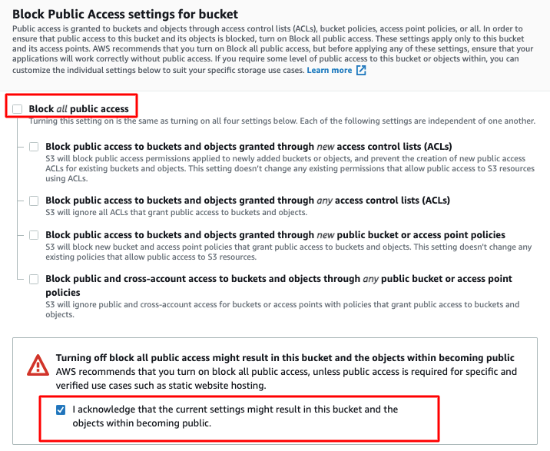
   * No need to change anything further, just click on the **Create bucket** button.

Task 3: Upload a file to an S3 bucket

1. Enter the S3 bucket by clicking on your bucket name.

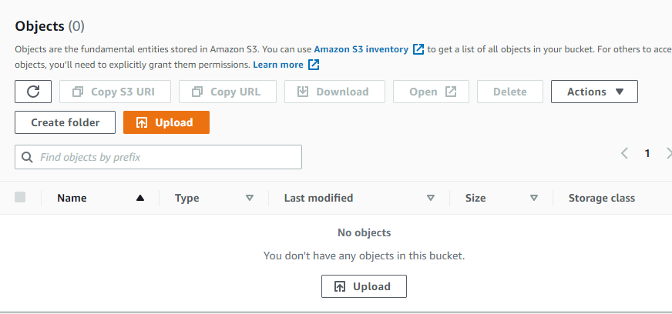

1. You can upload any image from your local machine or you can download our sample index.html image from [Download Me](https://play.whizlabs.com/site/download_file3?file=sample.html).
2. To upload a file to our S3 bucket,
   * Click on **Upload**.
   * Click on **Add files**.
   * Browse for your local image or the image we provided and select it.
   * Click on the **Upload**button.
   * You can watch the progress of the upload from within the transfer panel at the bottom of the screen.
   * Once your file has been uploaded, click on **Close**and you can see an object in the bucket.
   * **Note: Uploading files other than index.html will result in validation failure. Please upload the same index.html file only.**  
     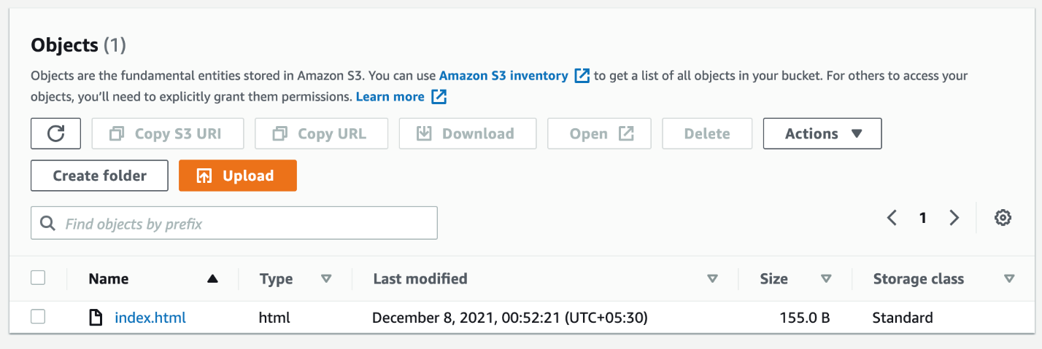

Task 4: Make the objects publicly accessible

1. Click the **Permissions**tab to configure your bucket.
   * In the **Permissions**tab, **Edit** the **Bucket Policy**.
   * You will be able to see a Blank policy editor.
   * Before creating the policy, you will need to copy the **ARN** (Amazon Resource Name) of your bucket.
   * Copy the **ARN** of your bucket to the clipboard. It is displayed at the top of the policy editor. it looks like **ARN:“arn:aws:s3:::your-bucket-name**".
   * In the policy below, update the bucket ARN on the Resource key-value and copy the policy code.
2. Copy the bucket policy.

|  |
| --- |
| {  "Id": "Policy1",  "Version": "2012-10-17",  "Statement": [  {  "Sid": "Stmt1",  "Action": [  "s3:GetObject"  ],  "Effect": "Allow",  "Resource": "replace-this-string-with-your-bucket-arn/*",  "Principal": "*"  }  ]  } |

1. 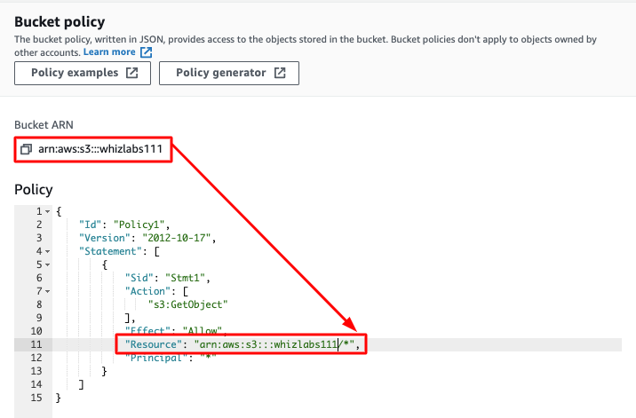
2. Click on **Save changes**.  
   

Task 5: Creating CloudFront Distribution

1. Select **CloudFront** under **Networking and Content Delivery**from the **Services** menu.
2. Navigate to the left side and click on icon. Select **Distributions**tab.
3. Now click on the 
4. Now configure distribution as follows
   * Origin Domain Name
     + On click of input space, select your S3 bucket:**whizlabs1234567.s3.us-east-1.amazonaws.com**
5. No need to change anything in configuration, scroll down and click on the **Create Distribution** button
6. You can see the CloudFront is **enabled**
   * **Note:**This process will take around **10-15** minutes.
7. The domain name that Amazon CloudFront assigns to your distribution appears in the list of distributions.
8. Copy and paste the domain of CloudFront distribution in the new tab of your browser.
9. It will throw an error because the S3 bucket is having object index.html and to access that enter the same in the path.
10. Copy and paste the domain of CloudFront distribution in the new tab of your browser and add **/index.html** in the URL.
11. It should display the index.html page present in the S3 bucket.  
    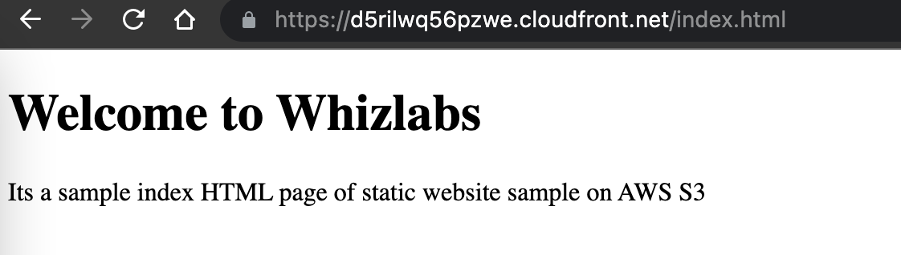

Task 6: Launching an EC2 Instance

1. Make sure you are in**US East (N. Virginia) us-east-1**Region.
2. Navigate to EC2 by clicking on the **Services** menu in the top, then click on **EC2**in the **Compute** section.
3. Navigate to **Instances** from the left side menu and click on 
4. Under the **Name and tags** section :  Name - ***MyEC2server***
5. **Choose an Amazon Machine Image (AMI):** Search for **Amazon Linux 2 AMI.**  
   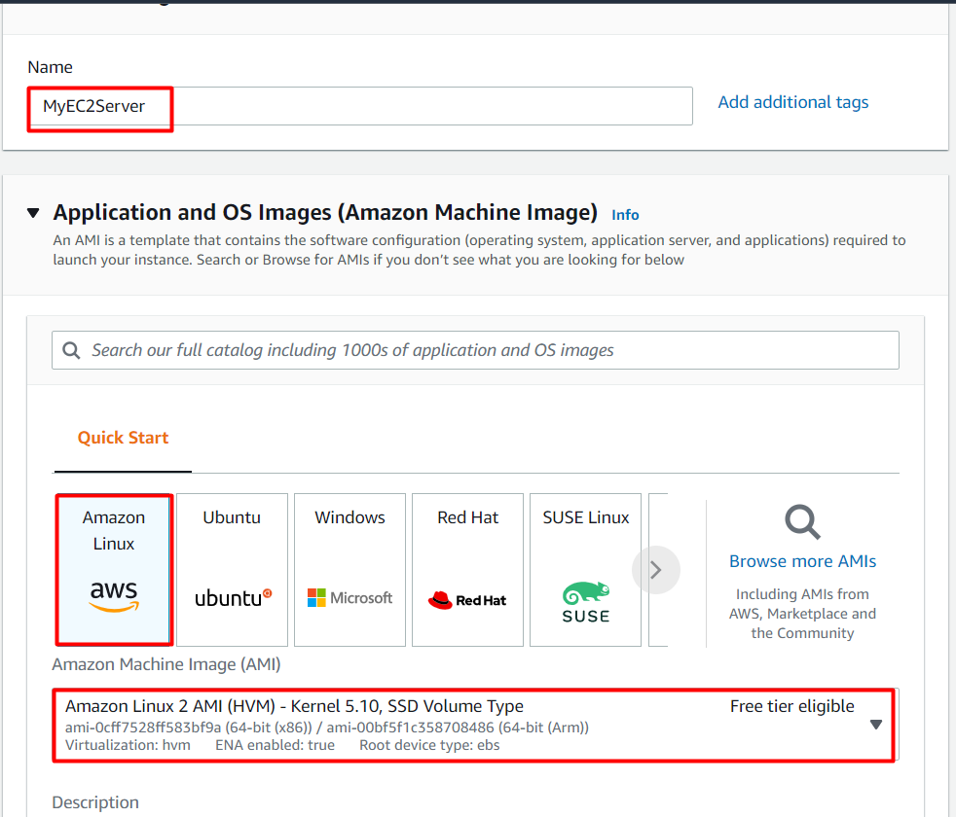
6. **Note: As there are two AMI present for Amazon Linux 2, you can choose any one.**
7. **Choose an Instance Type:** select **t2.micro.**

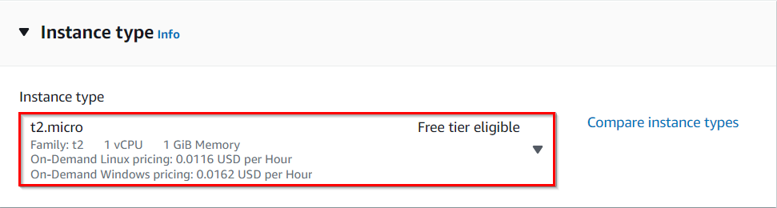

1. **Keypair Details:** No need to generate Keypair for this instance, you can proceed without a keypair.
2. Under the **Network Settings**section **:**

* Click on **Edit** button.
* Leave the default VPC as it is.
* Subnet**:**default subnet
* Auto-assign public IP: select ***Enable***
* Firewall (security groups) : Select **Select Create  security group**
* Security group name : ***MyEC2Server_SG***
* Description : ***Security Group to allow traffic to EC2***

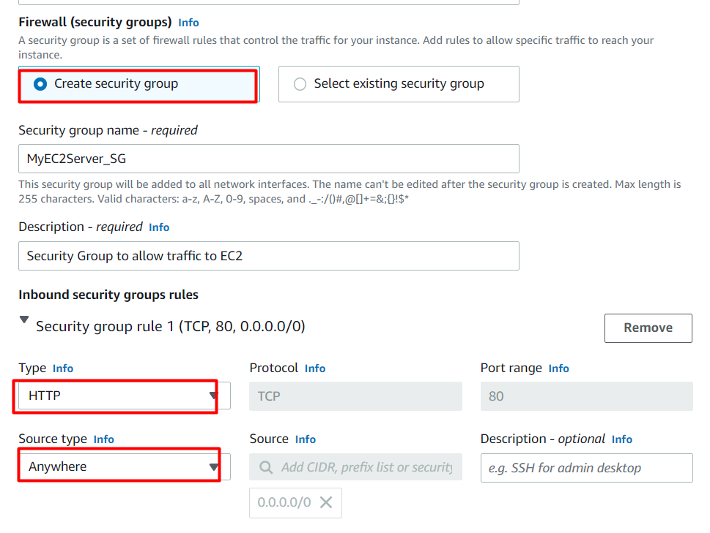

1. **Click on Advanced Details :**Scroll to the end and paste the below script in the**user data section.**

|  |
| --- |
| #!/bin/bash    yum update -y    yum install -y httpd.x86_64    systemctl start httpd    systemctl enable httpd    echo "<h1>Hello, this index.html page from $(hostname -f)</h1>" > /var/www/html/index.html    echo "<h1>Hello, this index2.html page from $(hostname -f)</h1>" > /var/www/html/index2.html |

1. Keep everything else as default and click on the button.
2. You will be asked for Keypair, select proceed without a Keypair and Click on **Launch Instances** button.
3. 13. After 1-2 minutes, the **Instance State** will change to **running**.

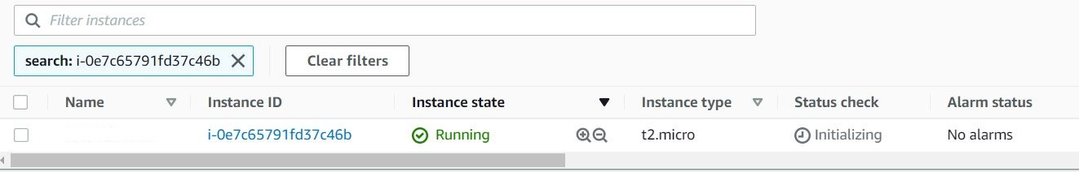

**Note down the sample Public IPv4 DNS Address of the EC2 instance.**

1. Try accessing the Public IPv4 DNS address by pasting in the browser, you will see the response as present below.

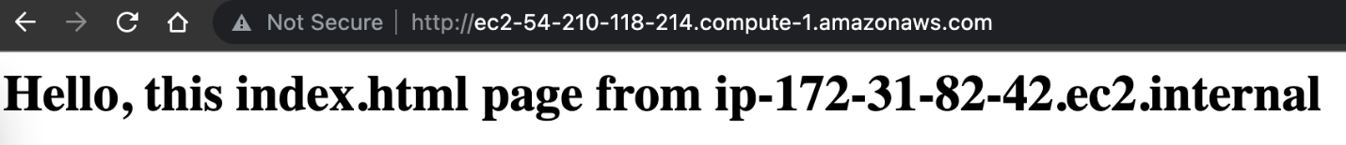

1. Now add **/index.html**in the URL.



1. Now update the URL by modifying /index.html to **/index2.html**

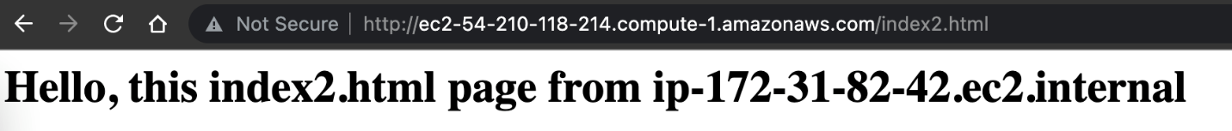

Task 7: Add EC2 as the Origin and create Origin Group

1. Before adding EC2 Instance as Origin, make sure CloudFront distribution is having Enabled status [here](https://console.aws.amazon.com/cloudfront/v3/home?region=us-east-1#/distributions).
2. Once the CloudFront distribution is having Enabled status, click on the ID to add the origin.  
   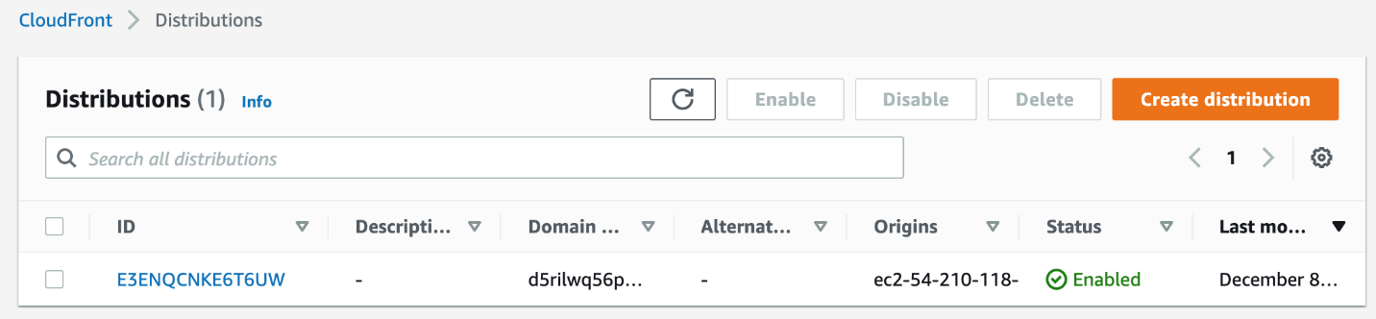
3. Switch to the **Origins** tab and click on the **Create origin** button.  
   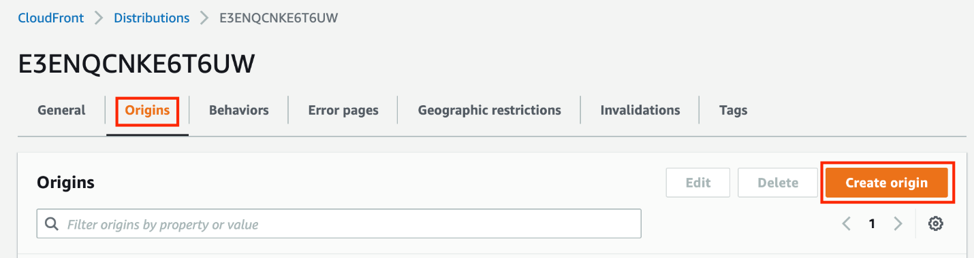
4. In the first option **Origin domain**, paste the copied Public IPv4 DNS of EC2 Instance.
5. Once pasted, all the details of the Origin domain will be listed below.
6. Keep all the options as default and click on the **Create origin** button.
7. Now there are two origins present.  
   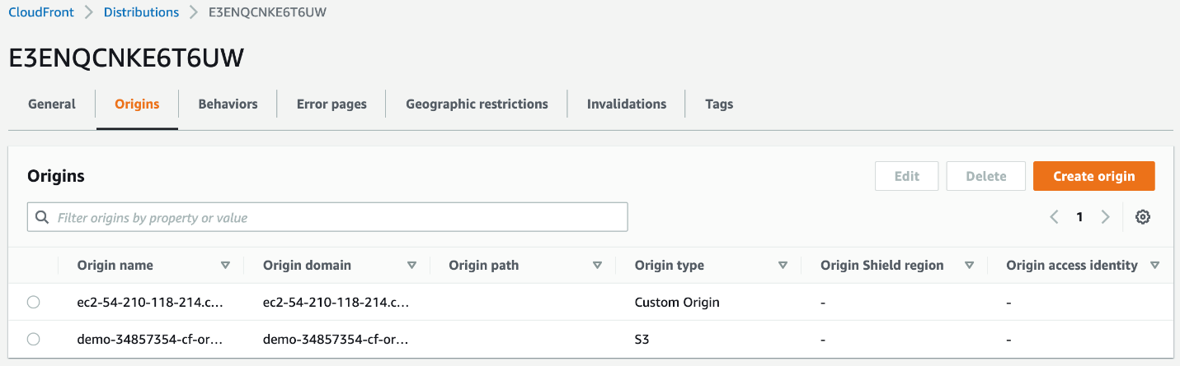
8. Scroll below and click on the **Create origin group** button.
9. Select the Public IPv4 DNS of EC2 Instance and click on the **Add** button.
10. Similarly, select the S3 Bucket endpoint and click on the **Add** button.
11. Once both the Origins are added, Give a name as ***Whiz-Origin-Group*** in the next field.
12. For the failover criteria, Select **404 Not found** error code present.
13. Once done, click on the **Create origin group** button.
14. Origin group is now created.  
    
15. Now Switch to the **Behaviors** tab.
16. Select the present behavior and click on the **Edit** button.
17. On the **Edit behavior** page, for the **Origin and origin groups** option, select the present Origin Group i.e. **Whiz-Origin-Group** from the dropdown.
18. Scroll to the end of the page and click on the **Save changes** button.
19. The default cache behavior is now updated to the Origin group.  
    
20. Go back to the **General** tab, you will see these changes are getting deployed.  
    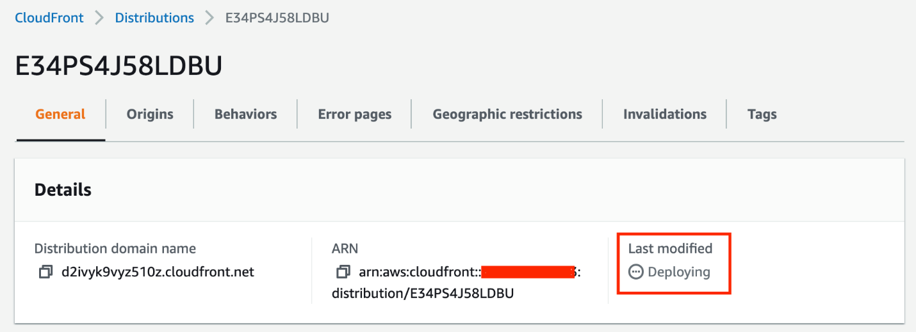
21. Wait for 5-10 minutes until you see the Deploying status changes and the **Last modified time** is present.  
    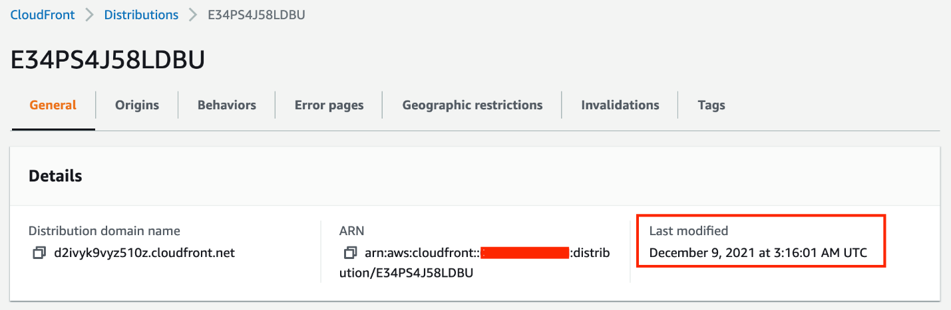
22. Now you can test the origin group.

Task 8: Test the Origin group

1. Copy the Distribution domain name and paste it into the new tab of your browser.
2. This should now display the index.html page from EC2 Instance as it has the Private IP DNS name.  
   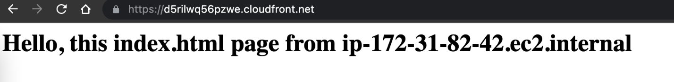
3. Now add **/index.html** into the URL. This displays the contents of the index.html file present in the S3 Bucket.  
   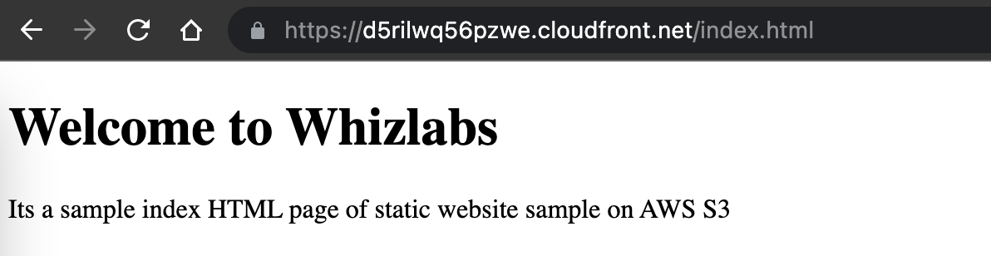
4. Now update the URL by changing /index.html to **/index2.html   
   **

Task 9: Validation Test

1. Once the lab steps are completed, please click on the  button on the left side panel.
2. This will validate the resources in the AWS account and displays whether you have completed this lab successfully or not.
3. Sample output :   
   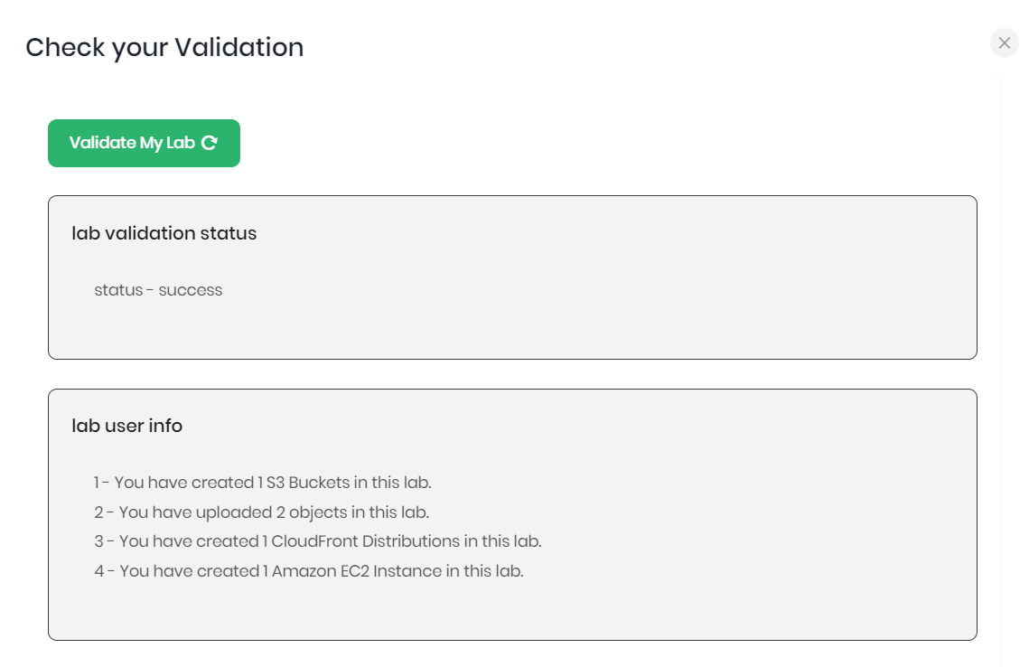

**Completion and Conclusion**

1. You have successfully created an S3 Bucket, uploaded index.html, and made the bucket publicly accessible using bucket policy.
2. You have successfully created an Amazon CloudFront distribution and published the S3 bucket's index.html file through CloudFront.
3. You have successfully launched the EC2 Instance and tested the Public IPv4 DNS of the instance.
4. You have successfully created the origin and origin groups in CloudFront.
5. You have successfully tested the failover using the distribution domain name.

**End Lab**

1. Sign out of AWS Account.
2. You have successfully completed the lab.
3. Once you completed the task, click on  from your whizlabs dashboard.

1h 24m 31s left

End Lab[Open Console](https://947289202677.signin.aws.amazon.com/console?region=us-east-1)Validation

Lab Credentials

User Name



Password



Access Key



Secret Key



Support Documents

Need help?

* [How to use Hands on Lab](https://business.whizlabs.com/labs/support-document/labs-instructions-and-guidelines)
* [Troubleshooting Lab](https://business.whizlabs.com/labs/support-document/lab-troubleshooting-need-help)
* [FAQs](https://business.whizlabs.com/labs/faqs-labs-general)

Submit Feedback

Share

* [About Us](https://www.whizlabs.com/about-us/)
* [Instructions and Guidelines](https://business.whizlabs.com/labs/instructions-and-guidelines)
* [FAQ’s](https://business.whizlabs.com/labs/faqs-labs-general)
* [Contact Us](https://www.whizlabs.com/contact-us/)

[](https://business.whizlabs.com/labs/)© 2023, Whizlab